PCB DESIGNING

21st & 26th February, 2018

G H Patel College of Engineering & Technology

**Introduction**

IAS-PES Joint Chapter, IEEE GCET SB arranged a workshop on P.C.B Designing for 4th semester EC students. It was conducted in 2 sessions. First session was conducted by Prof. Kavindra Jain, Prof. Neha Upadhayay and Prof. Chetna Shah on 21st February, 2018. Second session was conducted by Dr. Bhaskar Thakkar on 26th February, 2018.

The event was scheduled from 01:30 PM to 03:30 PM.

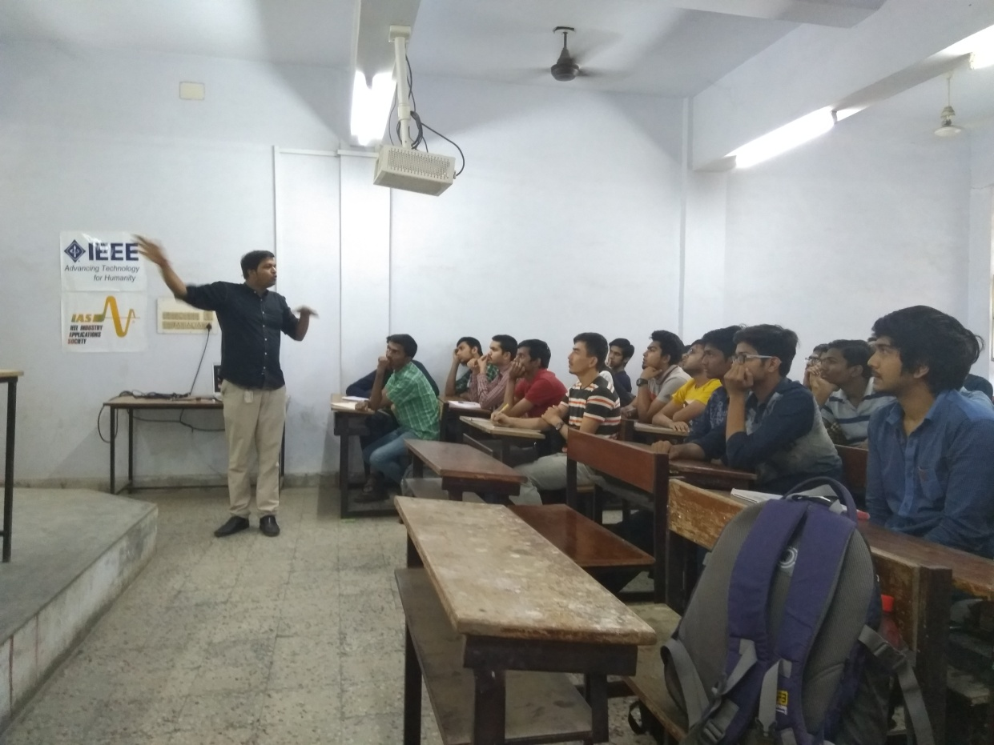

**Session 1**

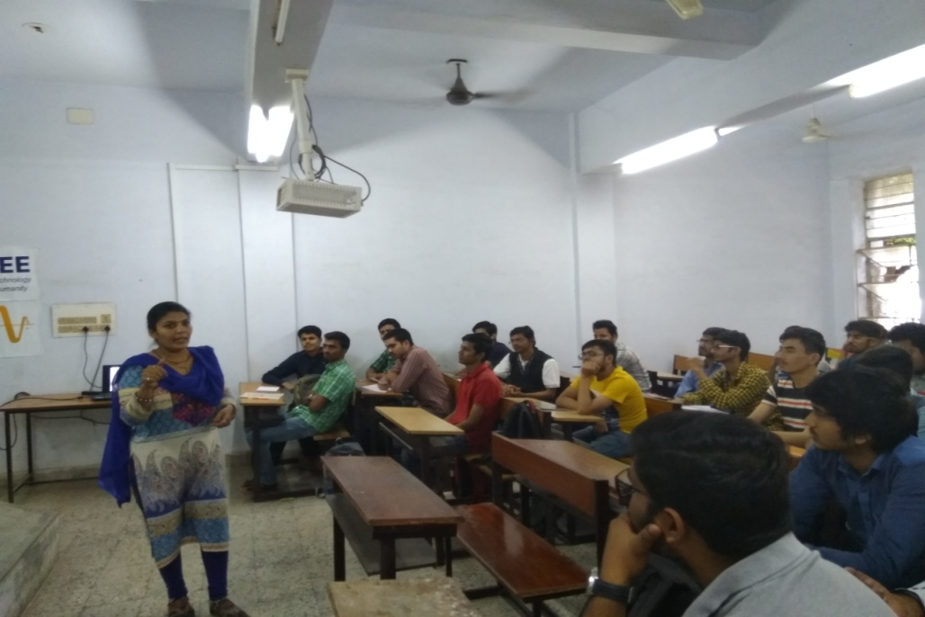

First session was conducted by Prof. Kavindra Jain, Prof. Chetna Shah & Prof. Neha Upadhayay. The session started at 01:30 PM and it focussed on the construction of PCB i.e. how the PCB is being constructed, what are the steps for the construction of PCB. Designing of a PCB is a long process which needs a lot of concentration and knowledge. The software part i.e. the designing/simulating of the PCB can be even done on smart phones through different applications available on the Playstore (e.g.: PCB droid). The following are the information for circuit designing and testing of PCB:-

1. Validation to software
2. Simulation
3. Components testing (if any)
4. Creating a GARBAR file
5. Converting into .pdf file
6. Print on drusy paper
7. Ambushing the print on PCB
8. Checking the circuit for any cracks
9. Filling the same using marker
10. Etching the PCB
11. Removal of Copper components from PCB except the circuit
12. Using sandpaper to remove the rest of the portion after taking it out
13. Using solution of baking soda and water to remove the marked circuits
14. Cleaning the PCB using water
15. Drilling the PCB
16. Mounting the set of components
17. Soldering the same
18. Desoldering the connecting parts.

After completing all the steps you will find that your PCB designing is completed. Basically the session was all about how the PCB board is constructed externally. The session concluded by 03:30 PM.

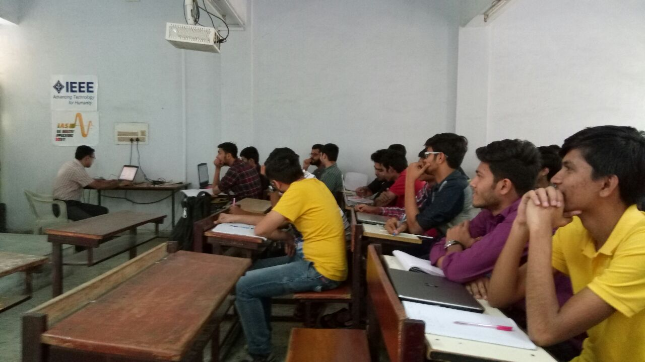

**Session 2**

Second session was conducted by Dr. Bhaskar Thakkar. It started at 01:30 PM and the session was all about the software. The session was totally practical, students were given live demonstration of what they were learning. “EAGLE” is the software which was used for the live demonstration. There are many software available for PCB designing. Some key points discussed in the session are:

1. .sch = schematic file
2. .lbr = library file
3. .bdr/.pcb = PCB file
4. Footprint = the physical dimension. These are present in the library file.
5. Via = Provide bottom layer electrical connection to top layer.
6. Polyconeplane = Empty region connected on ground for noise reduction.
7. GARBAR file = It has all the information about the tracks in the circuits. It does not have any information about the IC used.
8. There are a few sites which can be helpful for getting more information namely sparkfund.com, sunroom.com

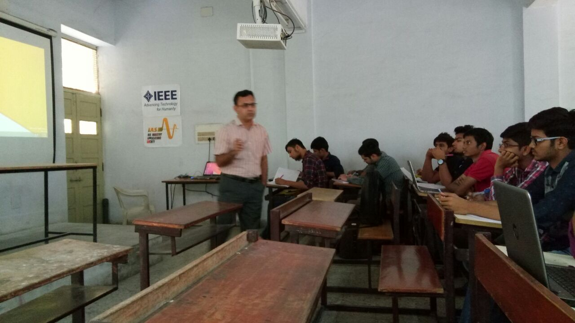

The following are the steps to use EAGLE software for construction of PCB:

1. Go to ‘Example’
2. New folder
3. New schematic
4. Select library (open)
5. Add (search option is available)
6. Grid option (show lines)
7. Prepare the circuit
8. Tools (autorouter)
9. Select layer and then “/” or N/A or Auto
10. Route (to change the width of the ned)
11. Change (will provide the option to change various parameters)
12. Generate the GARBAR file

After completing all the above steps the internal designing of the PCB is completed. This session successfully concluded at 03:30 PM.

